|  |
| --- |
| Oregon State University |
| Don’t Build Here! |
| An analysis of agricultural land in the Willamette Valley that is under threat of urban development and earthquake-induced soil liquefaction |

|  |
| --- |
| Aradia Farmer  Geog361, Spring 2018 |

# Introduction

The Willamette Valley is primarily made of excellent agricultural land, being a floodplain for the Willamette River. The fine, silty soil produces excellent crops year after year (see map 1). The agricultural products that are produced in the Willamette Valley, ranging from valuable economic exports like grass seed to important food sources like corn, are vital contributors to Oregon’s economy (Oregon Working Lands Report, 5). As the climate changes and the population increases, there will be an ever-increasing demand for food crops. Allowing vulnerable housing infrastructure to replace highly valuable agricultural land is a two-fold mistake, as it places more people in harm’s way while also reducing local food production.

During the late Pleistocene era there were repeated formations of what is known as Glacial Lake Missoula. This lake was formed by ice sheets damming a river in northern Idaho, which then periodically melted and released hundreds of cubic miles of water to rush down the Columbia River Gorge towards the Pacific Ocean. The volume of water was so great, and the canyons it had to pass through were so narrow, that it actually hydrologically dammed itself on the way, filling up the Willamette basin with a lake 100 miles long and 300 feet deep. The rich soils of Montana and Washington were stripped away from their place of origin by the ferocity of these floods, and then dropped in thick beds over 15 feet deep all along the valley floor (Bishop, 227). These complex layers of alluvium are generally characterized as mollisols, which drain slowly and retain fertility for a long time (Frederick, 5). All of this makes the Willamette River floodplain an appealing and worthwhile place to grow crops.

The Willamette Valley is undergoing rapid urban expansion. Eight of the ten most populous cities in Oregon are in the Willamette Valley, and the population of the state is estimated to increase to over 5.5 million people by 2050 (Oregon Working Lands Report, 13). This is causing tension with agricultural land owners, as well as with the conservation groups that work to keep Oregon’s natural habitats healthy and functioning. Finding ways to corral urban growth, preserve the environment, and keep the state economy robust is a challenge that will not be quickly or easily resolved (The Willamette Story).

Lurking beneath these relatively short-term challenges lies something much larger. The entire Pacific Northwest is almost certainly going to experience a large earthquake sometime in the next 50 years (Atwater et al. 101). The Cascadia Subduction Zone is now a commonly discussed hazard in households up and down the state, but its discovery is recent enough that few statewide policies have yet taken it into account. When it happens, liquefaction of soils is going to be a serious hazard all up and down the Willamette Valley and elsewhere (DOGAMI; Atwater et al., 22). The story of Cascadia’s discovery is a delightful detective mystery that is well documented in The Orphan Tsunami by Atwater et al., but the impact of this important research is still mostly limited to academic circles and has yet to become a common feature in most disaster planning. Most urban planners and even some natural hazard planners are still ignorant of Cascadia entirely, or have not fully taken into account all of the ramifications that will result from 4-6 minutes of seismic shaking.

Liquefaction is a process that occurs during prolonged seismic shaking, in which small, unconsolidated particulate substrates (sand, silt, soil) begin to flow like fluids (Pathack and Dalvi, 431). Liquefaction is one of the unsung villains of earthquake hazards, causing large amounts of the damage to buildings and accounting for much loss of life (Pathack and Dalvi, 425). This causes buildings to tilt and sink into the earth, while also allowing buried pipes and tanks to float to the surface (Wang et al.). Bridges, power poles, retaining walls, and other rigid structures will also fare poorly under these conditions. However, the soil itself is not radically changed once the shaking stops. A field that has experienced liquefaction may lose its current crop, but it can be replanted next year as if it had not been shaken. Therefore, the damage that a farm will take during a seismic event will be much less than the damage a suburban housing development will experience. In terms of risk reduction, building homes in areas with a high liquefaction potential is a poor tradeoff in exchange for losing food production on highly fertile soils.

The use of GIS for geospatial analysis and decision making in agriculture is still in its infancy, and its true potential has yet to be fully realized (Ahmad et al., 203). This project’s results, as well as its shortcomings, provided the author with much fuel for thought about how to extend the use of GIS into other research projects, both personally and in general.

# The Analysis Project

Considering the triple threats of population growth, food shortages, and earthquake hazards, it was decided to perform a suitability analysis on the land in the Willamette Valley that is currently being used for agriculture. The analysis investigated the intersections of crop production, predicted urban growth, and soil liquefaction potential. A map of the Willamette River Basin areas that should remain as agricultural land despite the pressures to expand urban environments was produced, since agriculture will be in far less danger of damage during an earthquake event. The most speculative of these factors is the projected urban growth, which was modeled with the DevelopmentTrend2050 created by the Ecosystem Research Consortium in 2002. This problem is at the heart of the intersection between economic, social, and environmental concerns (Javadian et al., 74).

Often, analyses such as these are performed to prevent damage to the environment (Kharo et al., 29), but there is no reason that it cannot be done to prevent damage from the environment instead. Considering climate change, population growth, and the unpredictable yet ultimately inevitable occurrence of a large earthquake in this region, this analysis can provide insight into the urban growth decisions facing all centers of urban growth in the Willamette Valley over the next few decades. It is not enough to just develop land according to short-term profits, the long-term multi-generational use of a given plot of land must also be considered in a truly sustainable development plan for a region (Javardian et al., 73).

At the outset of the project, it was assumed that areas which are highly prone to liquefaction are also highly agriculturally productive, and that these areas are likely to be highly favored for future urban growth. To test this assumption, three layers of raster data were produced, then added together. To clearly delineate areas that were not yet developed vs those that were already developed a polygon of 2017 urban growth boundaries was cut out of all three data layers. This served a dual function of removing areas that were out of the running for being protected from urban development (as they were already developed) and also allowed the basemap to show through the data layers for easy visual reference during the analysis process and in the final map products. Areas which met the three criteria were selected and highlighted in the final maps, included at the end of this document.

The purpose of this process was to locate areas in the Willamette Valley which should be preserved as agricultural land in spite of increasing pressure to convert to urban development. Throughout the Pacific Northwest, the pressures between agricultural production, population growth, and increasing awareness of seismic hazard are a topic of conversation and contention. This analysis is meant to shed some light on the balance between the potential for economic production vs seismic risk in light of potential urban growth (Samad and Morshed, 24).

Suitability analysis requires considering as many factors as possible. This can be done by numerically classifying the various spatial attributes of the layers of interest, combining them, and then reclassifying the results to produce an overall suitability score (Chow and Sadler, 9). The final step will be in interpreting that suitability score in a way that a non-geographer can understand, since the purpose of this analysis is to inform urban planning and policy decisions over the next few decades.

# Methodology

To identify which areas that are currently under cultivation should remain so despite even the most enthusiastic development plans, three layers of data were produced: *which croplands are most valuable, which areas are predicted to see urban growth by 2050,* and *which areas are most prone to liquefaction*. This produced a result of clearly identifiable parcels of land which are prime candidates to be left alone to continue producing commercially significant crops rather than putting new homeowners in greater danger than is strictly needed.

The layers that were selected for this process were Prime Farmland (produced by the Natural Resource Conservation Service), total Cropland (produced by the United States Department of Agriculture), Development Trend 2050 (produced by the Ecosystems Research Consortium), Urban Growth Boundaries 2017 (produced by various agencies within the state of Oregon), and Liquefaction Potential (produced by the Oregon Department of Geology and Mineral Resources). These layers all came in high resolution of 30 meters. It is entirely possible, if not probable, that other data layers could have been included in this analysis that would either have made the results more nuanced, more accurate, or both.

Initial data processing included ensuring that all datasets were in the same geographic projection and clipping the data to the area of interest. Then the data had to be converted from vector to raster, if it wasn’t already in raster format, and reclassified into categories that were relevant to the analysis. Once this layer preparation was completed, the layers were added together with a raster calculator to find the intersections of interest, and a new layer of only those selected areas was produced. This phase of the analysis was one that could have been repeated iteratively, changing the relative value of each of the layers in an exploratory fashion, had time permitted. Considering the relative weight of the factors (Javardian et al., 76) or taking into account stakeholder opinions (Chow and Sadler, 10) could have potentially changed the conclusions of this analysis radically.

For reasons relating to author inexperience and limited time, the classification scheme was perhaps not the most efficient, but it did produce results similar to what this author expected to find. Future work on this topic could be made more efficient by reworking this step. Alternatively, the soil liquefaction or prime cropland layers could have been entirely produced in this analysis using remotely sensed data and criteria chosen by the author rather than simply accepting the conclusions of another team. This would have taken much more work, but could potentially have produced layers more suited to the specific criteria desired for this particular analysis (Ahmad et al., 205).

*Cropland* was categorized as being either subprime (values 1-999) or prime (values 1,000-1,247), *liquefaction* was categorized as being on a scale of 1-5 multiplied by 10,000 (values 10,000-50,000), and *potential growth* was categorized as being urban (values 1-100,000) or some other category (100,001-999,999). Added together this produced a value-field between 1,000 and 1,050,142, of which the range of values between 141,000 and 151,000 represented the areas of interest. By giving each category its own order of magnitude, the addition of values produced a result that was expected and easily understood in the amount of time remaining for the project. Future work with these data could certainly find a less obscure way to extract the intersections of interest. Reviews of other methodologies (Solekar et al.) certainly seemed to be less cumbersome.

Several issues were encountered during this analysis, including inconsistent metadata standards used in the production of the datasets, unfamiliarity with raster data analysis on the part of the author, and the particular style of file paths used by the author that were incompatible with the ArcMap software. Many aspects of the data that would have been interesting to explore, such as total area considered for various types of urban growth or total area given to certain types of food or nonfood crops, or the projected change in crop types on sub-prime agricultural land, were unfortunately unable to be explored in this particular iteration of this analysis project. This information was preserved in the data layers used in this analysis, so future projects could build directly on this work without having to go back to the raw data that was downloaded from various data clearinghouses.

Many of the issues in layer processing that were encountered were as much the product of poor comprehension of the limitations of the tools as they were the product of the limitations of the tools themselves. The author vastly overrated their understanding of the software or how to think through the options presented therein. Future work of this scope should ideally be done in a team with more experienced members being more closely involved in the early stages of workflow planning and execution. Geographic information systems are a powerful tool, but they are still only software packages that rely on a deep understanding of their function to come from the human end user.

Version 10.6 of ArcMap and ArcCatalog (produced by ESRI) were used for this analysis. The author would like to extend deep gratitude to the teacher of this class for repeated meetings in which tools and methods were examined and refined, as well as flexible due dates for completed work.

# Workflow diagram in Four Stages

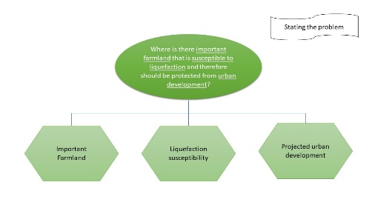

Figure Stating the Problem

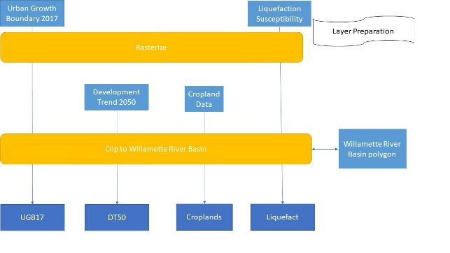

Figure Layer Preparation

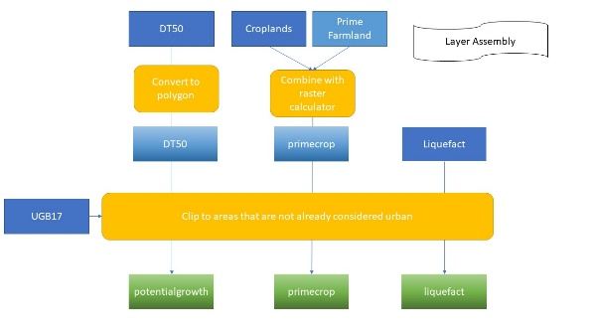

Figure Layer Assembly

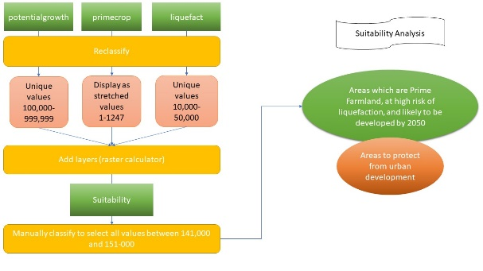

Figure Suitabilty Analysis

## Metadata table

|  |  |  |  |  |  |  |  |  |  |  |
| --- | --- | --- | --- | --- | --- | --- | --- | --- | --- | --- |
| **Layer Name** | **Date** | **Original scale** | **PCS** | **GCS** | **Author** | **Attributes** | **Quality** | **Method of creation** | | **Relevance** |
| Prime Farmland | 2009 | 30 meters | Lambert Conformal Conic | NAD83 | Natural Resource Conservation Service (NRCS), Soil Survey Geographic Database (SSURGO); State Soil Geographic Database (STATSGO) | Soil data; raster | Only for prime farmland; almost 20 years out of date | | Derived from digital soil data | Shows land that should be preserved from development from an ag perspective |
| Cropland Data Layer (by state) | 2017 | 30 meters | UTM 11N | WGS84 UTM11 | USDA, National Agricultural Statistics Services (NASS) | Crop-specific landcover; raster | No farmer-derived data, just images  Classification accuracy is 85%-90% correct | | Satellite imagery | Shows all land currently under cultivation, and what is being cultivated |
| Oregon Urban Growth Boundaries 2017 | 2017 | 40 feet | Lambert Conformal Conic | NAD83 | Oregon Department of Land Conservation and Development, ODOT, Metro Regional Council of Governments (Metro), county and city GIS departments, ODAS-GEO | Urban boundaries; vector | DP2050 was made with 1990 UGB in mind, this is from 2017 | | Multi-agency collaboration | Areas that are already being developed |
| Liquefaction Susceptibility 100k-- | 2006 | 1:100,000 | Lambert Conformal Conic | NAD83 | DOGAMI | Soil liquefaction susceptibility; raster | Estimate from over 10 years ago | | LiDAR, geologic survey, geographic analysis | Soil liquefaction susceptibility |
| Development Trend 2050 | 2002 | 1 acre minimum mapping unit | Lambert Conformal Conic | NAD83 | Ecosystem Research Consortium | Vector and raster data; modeling | Modeling | | Simulation | Simulation of year 2050 land use and land cover |

# Results

Each of the layers that was processed produced results that were unsurprising to someone even superficially familiar with the area of interest. The Willamette Valley is notorious to residents for its high agricultural production, particularly during field-burning season. Similarly, the press outward from current urban growth boundaries into the surrounding landscape is a familiar refrain going back decades in the memory of older residents. The liquefaction potential is a recently discovered threat that was only examined once the Cascadia Subduction Zone was identified as a regional hazard, but it is not surprising that this potential radiates outward from the alluvial floodplain defined by the historical spread of the Willamette River. Likewise, the fertility of the valley is clustered along the Willamette and its tributaries in typical accordance with the nature of floodplains and agricultural production worldwide.

The results of this spatial analysis were a selection of 57 parcels of land that exist at the intersection of prime farmland, urban development by 2050, and high to very high liquefaction potential. These parcels were all clustered along the edges of currently existing urban growth boundaries as of 2017. These results were not surprising except in their scarcity. The Willamette Valley is highly agriculturally productive and is also experiencing rapid population growth, so the author expected to find solid rings of this intersection of values around most towns in the area of interest. Instead, the results indicated only a spotty fringe around some cities, with other areas being completely devoid of this particular combination of factors.

Though the analysis produced a list of parcels that should be protected from further development, it is wondered if the number of these parcels could be increased if other factors were taken into account, or if the classification schemes were constructed differently. Given that these areas are of high value with respect to future urban development, it is likely that the reasons for preserving these parcels as agricultural land will be stridently challenged by city planners, and so the justifications for this analysis would need to be soundly supported with further research and perhaps a more robust analysis process.

# Discussion

The author was surprised at how few areas were at the triple-junction of the three criteria laid out in the research question (see map 2). Geologically speaking, the Pleistocene was an eye-blink ago, so it seemed intuitive to think that the dangers of lake-bottom sediments would be fairly equally spread across the valley floor. However, as with any natural process, once a topic is examined in depth it tends to prove to be far more complex than it appeared at first glance. It is suspected that if more factors were included in this analysis, or if the margins of safety were redefined in a broader, more conservative way, the total area included in the “do not build here” category would be significantly greater. Additional data that would help to inform a second analysis building on this work would include total agricultural productivity both in terms of total economic value and in terms of food that could be produced for local consumption.

Significant problems with this analysis that hampered a more thorough analysis that the author wished to perform at the start of the project included the author’s unfamiliarity with the process of rasterizing vector data, data layers that had far more detail in their classification than was needed for this analysis (resulting in significantly increased processing time, inconsistent metadata and projection data, limited computer processing power, and eccentricity between the author’s workflow and the ArcMap software protocols. Future work on this topic should keep these issues in mind, and allow for what may appear to be excessive amounts of time to overcome these challenges.

Future work on this topic could also include an analysis of soil types with respect to crop types, and an examination of any crops that are currently grown for economic benefit (such as grass seed) that could reasonably be converted into food crops to support a growing population. It would also be beneficial to consider updating the Development Trend dataset to something more recently produced, as population fluctuations and the patterns of urban development have probably shifted quite a bit since that trend was modeled.

It would also have been interesting to look at the spatial autocorrelation between crop value, soil type, and liquefaction potential. It is suspected that more areas of unanticipated vulnerability could be discovered if those associations were explored. It is also possible that an analysis of those factors could lead to other conclusions that would help prepare the Willamette Valley for the next several decades of increasing population growth in the face of climate change and decreasing soil fertility. The judicious planting of certain types of crops can improve soil productivity as well as improving population resilience to a wide variety of environmental threats and hazards (Ahmad et al., 202).

It is also worth noting that though food production was highly prized in this analysis, it has been discovered by other researchers that the Willamette Valley cannot wholly support the local population on locally produced food (Giombolini et al., 250). Nonetheless, the combined economic and nutritional benefits of keeping agricultural production high in the Willamette Valley are worth keeping in mind in this and future work in this vein. Considering the economic impact beyond simple food production could be an interesting direction for future work to go in.

Perhaps the most pressing unanswered question raised by the results of this analysis is “who owns the parcels identified as needing to be preserved?” Simply identifying the areas on the basis of professionally produced geospatial data layers is not enough to effect change. Had time allowed, identifying the current owners of these parcels and inquiring into their current and near-future plans for these parcels would have been a highly desirable next step. Any future applications of this process would need to consider how to take that step in order to be an effective land use analysis.

# Conclusion

The application of these conclusions, namely preserving land that is currently agricultural in the face of mounting pressure to expand urban development, may perhaps be a thornier issue than the ones the author encountered in performing the analysis. In a paper published in Conservation Biology, Fischer and Bliss discuss the challenges of preserving oak habitat on privately owned land in Western Oregon. They found that the perceptions of landowners towards the value of their land, both as ecological and economic resources, strongly influenced their relative desires towards preserving, harvesting, and managing small plots of land (Fischer and Bliss, 277). The pressure to develop for economic gain is a powerful motivator against the desire to preserve environments for their own sake, and the additional factor of earthquake risk may do little to sway decision makers. Though an earthquake may permanently change a person’s outlook on future events (Trumbo et al., 1016), this does little to convince someone who hasn’t yet experienced such an event and may not live to see one. The Cascadia subduction zone is not guaranteed to cause an earthquake in the next 50 years, despite the dire predictions made by many scientists, so though this analysis may be of interest to people planning for disasters it is also unlikely to sway developers who are eager to push the boundaries of Salem out just a little farther.

In general, though this analysis was more in depth than anything the author had done before, it was relatively limited and superficial compared to most of the work that has been done professionally. Looking at remotely sensed data directly, or even conducting actual field work into soil types or expert opinions (Zolekar and Bhagat, 306) could have provided a more personal feel for what the conclusions of this paper might look like on the ground as well as making the data less of a confusing jumble of classifications created by other researchers often removed from the analysis by decades. A more thorough review of the literature that has been published on the origin and evolution of Willamette Valley soils could also have provided a more nuanced approach to characterizing and investigating the relationship between economic value and risk assessment. On the other hand, using the work of others to make broad conclusions without having to recreate every step of the data along the way can be enlightening as well. In addition, the amount of knowledge that one must have in order to create data layers like the soil liquefaction potential is daunting and often requires exhaustive reviews of currently existing literature (Pathak and Dalvi, 425). The author would very much like to continue to explore this topic and related issues here in the Willamette Valley in the years to come.

## Bibliography

Ahmad, Firoz, et al. “Agroforestry Suitability Analysis Based upon Nutrient Availability Mapping: a GIS Based Suitability Mapping.” AIMS Agriculture and Food, vol. 2, no. 2, 23 May 2017, pp. 201–220., doi:10.3934/agrfood.2017.2.201.

Atwater, B. F., Musumi-Rokkaku, S., Satake, K., Tsuji, Y., Ueda, K., & Yamaguchi, D. K. “The orphan tsunami of 1700—Japanese clues to a parent earthquake in North America.” Professional Paper, 2005, doi:10.3133/pp1707.

Bishop, Ellen Morris. *In Search of Ancient Oregon: a Geological and Natural History.* Timber, 2010.

Chow, T. Edwin, and Richard Sadler. “The Consensus of Local Stakeholders and Outside Experts in Suitability Modeling for Future Camp Development.” Landscape and Urban Planning, vol. 94, no. 1, 2010, pp. 9–19., doi:10.1016/j.landurbplan.2009.07.013.

Fischer, A. Paige, and John C. Bliss. “Behavioral Assumptions of Conservation Policy: Conserving Oak Habitat on Family-Forest Land in the Willamette Valley, Oregon.” Conservation Biology, vol. 22, no. 2, 2008, pp. 275–283., doi:10.1111/j.1523-1739.2007.00873.x.

Gelderman, Frederick William. “Willamette and Associated Soils on Late Pleistocene Geomorphic Surfaces, Polk County, Oregon.” Oregon State University, 1970.

Giombolini, Katy J., et al. “Testing the Local Reality: Does the Willamette Valley Growing Region Produce Enough to Meet the Needs of the Local Population? A Comparison of Agriculture Production and Recommended Dietary Requirements.” Agriculture and Human Values, vol. 28, no. 2, Aug. 2010, pp. 247–262., doi:10.1007/s10460-010-9282-x.

Javadian, Marjan, et al. “Application of Sustainable Urban Development in Environmental Suitability Analysis of Educational Land Use by Using AHP and GIS in Tehran.” Procedia Engineering, vol. 21, 2011, pp. 72–80., doi:10.1016/j.proeng.2011.11.1989.

Khahro, Shabir Hussain, et al. “Land Suitability Analysis for Installing New Petrol Filling Stations Using GIS.” Procedia Engineering, vol. 77, 2014, pp. 28–36., doi:10.1016/j.proeng.2014.07.024.

“Oregon Working Lands Report.” The Trust for Public Land. 2015. <https://web.tplgis.org>. Accessed on 14 May 2018.

Pathak, Snehal R., and Asita N. Dalvi. “Elementary Empirical Model to Assess Seismic Soil Liquefaction.” Natural Hazards, vol. 69, no. 1, 2013, pp. 425–440., doi:10.1007/s11069-013-0723-x.

Samad, Rokshana, and Morshed, Khan Mahbub. “GIS Based Analysis for Developing Residential Land Suitability.” Journal of Settlements and Spatial Planning, vol 7, no. 1, 2016, pp. 23-34., doi:10.19188/03.jssp012016.

“The Willamette Story.” Willamette Basin Explorer. No date provided. <http://oe.oregonexplorer.info/story/story.php>. Accessed on 14 May 2018.

Trumbo, Craig, et al. “An Assessment of Change in Risk Perception and Optimistic Bias for Hurricanes Among Gulf Coast Residents.” Risk Analysis, vol. 34, no. 6, 2013, pp. 1013–1024., doi:10.1111/risa.12149.

Wang, Y., Bartlett, S., & Miles, S. (2012). “Earthquake Risk Study for Portland's Critical Energy Infrastructure Hub.” Oregon Department of Geology and Mineral Industries. Retrieved 15 May 2017, from <http://www.oregongeology.org/sub/earthquakes/cei-hub-report.pdf>

Zolekar, Rajendra Bhausaheb, and Vijay Shivaji Bhagat. “Multi-Criteria Land Suitability Analysis for Agriculture in Hilly Zone: Remote Sensing and GIS Approach.” Computers and Electronics in Agriculture, vol. 118, 2015, pp. 300–321., doi:10.1016/j.compag.2015.09.016.

## Maps

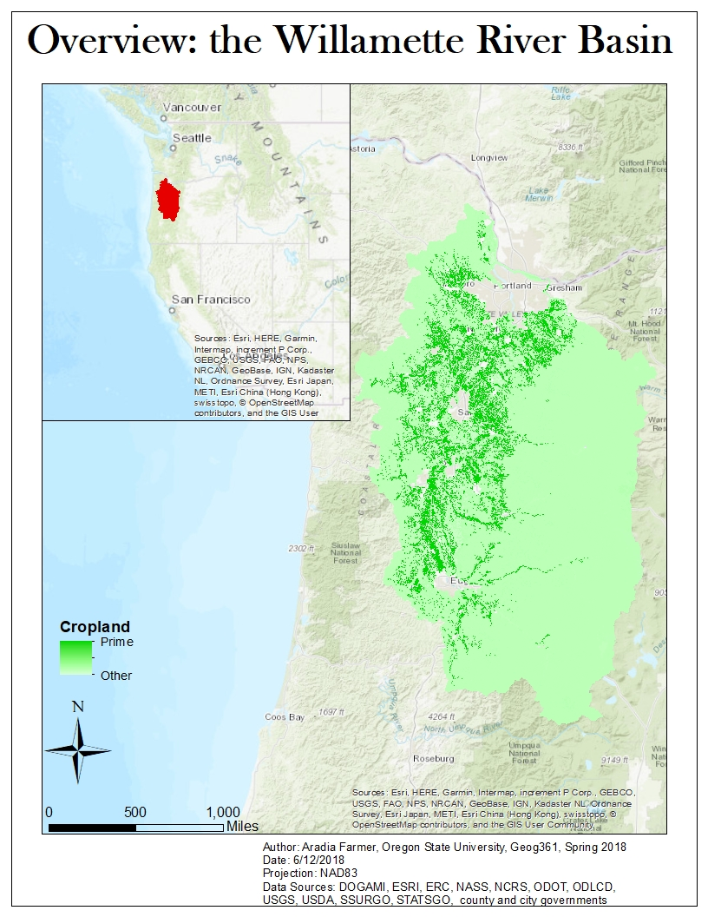

Map Overview of study area, with cropland types

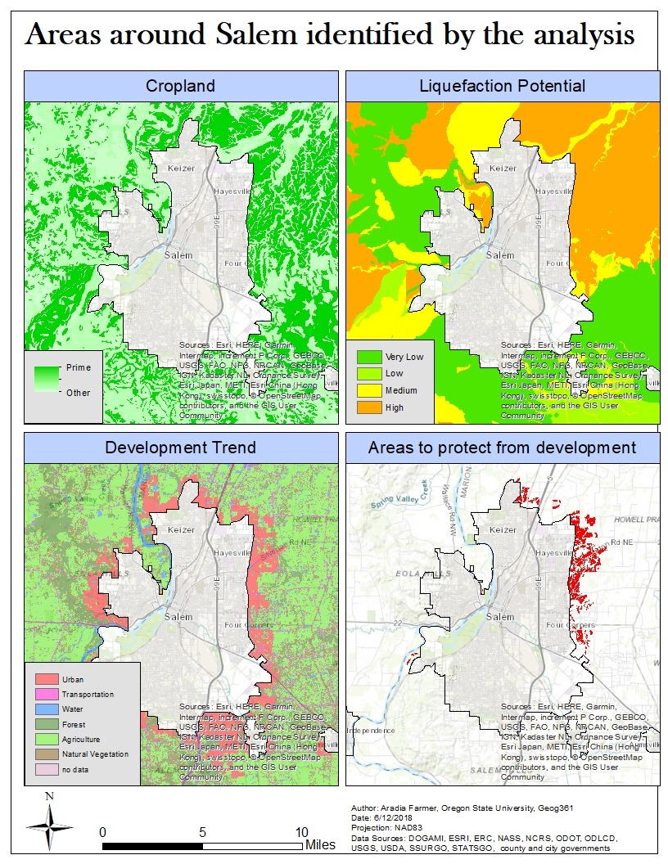

Map The three data layers that were produced, and the results of the final analysis